JOB DESCRIPTION

Official Job Title: | Admin/Finance Associate
Duty Station: | Johannesburg, South Africa
Grade (Classified) | G6
Post Number: | 130840
Post Type: | Rotational Non-Rotational
Classification Authority: |  | Date:

1. Organizational Location

The Admin/Finance Associate will support the work of the Joint UN Programme on SRHR/HIV in the East and Southern Africa Regional Office (ESARO) based in Johannesburg, South Africa. S/He reports to the Project Coordinator based at UNFPA ESARO and falls under the overall leadership of the HIV Prevention Advisor. The Admin/Finance Associate will provide administrative, clerical and logistical support to the technical and programme staff working on SRHR and HIV to ensure the effective implementation of UNFPA’s efforts on SRHR and HIV. S/He is overall responsible for providing: administrative support, managing the travel of the unit, supporting the procurement process for consultants, logistical and administrative support for the organisation of meetings, regional consultations, other events or activities being undertaken by the unit. Will develop and maintain an electronic filing system, databases and support the maintenance of electronic platforms for the sharing of information. The Admin/Finance Associate will work in close collaboration with the International Operations Manager at UNFPA ESARO and the operations team.

2. Job Purpose

The Admin/Finance Associate will provide administrative, clerical and logistical support to the SRHR/HIV Integration Unit. The Admin/Finance Associate will provide administrative, clerical and financial support to the SRHR/HIV Team at UNFPA ESARO. S/He is overall responsible for providing administrative support, managing the travel of the unit, support the unit in managing the managing the procurement process for consultants undertaking work on behalf of the unit, provide logistical and administrative support for the organisation of meetings, regional consultations and other events being organized by the unit. Maintain the record and filing system of the unit.

3. Major Activities/Expected Results

The Admin/Finance Associate will provide administrative, clerical and financial support to the SRHR/HIV Team at UNFPA ESARO. In particular the person will support the SRHR/HIV Unit with:

Administrative Support
Undertake and manage the day-to-day administrative needs of the SRHR/HIV Unit, this includes:

- Travel: Supports the unit to arrange programme visits including: prepare travel requests, itineraries, accommodation, and collates background information and preparation of reports.

- Consultants: Supports the unit to prepare the necessary documentation for the procurement of consultants, including
- Support the unit in ensuring that relevant consultants are added to the UNFPA Consultants Roster.
  - Preparation of the Terms of Reference.
  - Oversees and manages the recruitment process.
  - Prepares and finalizes the necessary documentation for submission to recruit the consultant.
  - Establishes a process to manage consultancies, including tracking progress to ensure that all deliverables are delivered within the contract period.
  - Supports the travel arrangements for consultants and where necessary works with countries to ensure that itineraries and all relevant background documentation is collated and provided to the consultant.
  - Ensures that all payments are prepared and submitted.

- Organization of regional programme meetings and events in accordance with UNFPA procurement rules and procedures, including:
  - Works with the Unit to develop a check list for meetings
  - Develop a participants list for the meeting
  - Identify and book venue’s, catering and accommodation
  - Draft and distribute letters of invitations to meeting participants.
  - Make necessary travel and accommodation arrangements
  - Collate and where necessary prepare the relevant background documentation in preparation for the meeting
  - Ensure that the meeting venue is set up and all audio-visual equipment is available.
  - Support the unit with the development of multi-media presentations
  - Take minutes of meetings when required
- Establish and maintain a range of basic databases and records systems including;
  - Creating electronic mailing lists
  - Set up and maintain a data base of contact persons at regional and country level for the SRHR/HIV and GBV Team.
  - Set up and maintain an appropriate office filing system
  - Maintain and update electronic platforms created to share information.

4. Work Relations

External partners include the programme's main donor (Sweden), UN agencies in particular the administrative focal persons for the regional teams of UNAIDS, UNICEF and WHO, donor as identified by partners. The participating governments in the Joint UN Regional Programme on SRHR/HIV and GBV Integration. Regional and international organizations and counterparts on issues including partner NGOs.

Internal partners include UNFPA International Operations Manager and the UNFPA ESARO operations team, programme and technical staff, the M&E Adviser, Communication Team. Administrative and programme staff located in the UNFPA country offices involved in the programme; relevant UNFPA headquarters units. In all activities, s/he supports the HIV Adviser and the Project Coordinator to ensure the effective and efficient administration of the Joint UN Regional Programme on SRHR/HIV Integration and the work on HIV prevention.

5. Job Requirements

Education:

6 years experience in providing administrative and financial support.

Experience of the financial and administrative procedures of UNFPA or another UN entity.

A basic degree or diploma is desirable.

Proven track record in delivering results.

Required Competencies:
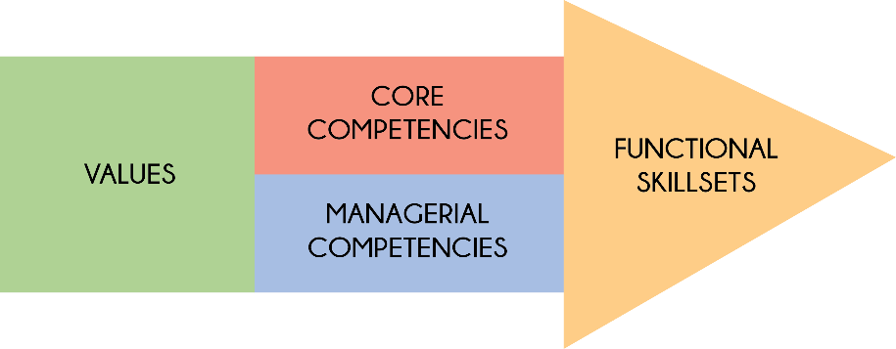
Values:
- Exemplifying integrity
- Demonstrating commitment to UNFPA and the UN system
- Embracing cultural diversity
- Embracing change

Core Competencies:
- Achieving results
- Being accountable
- Developing and applying professional expertise/ business acumen
- Thinking analytically and strategically
- Working in teams/ managing ourselves and our relationships
- Communicating for impact

Managerial Competencies:
- Providing strategic focus
- Engaging internal/ external partners and stakeholders
- Leading, developing and empowering people/ creating a culture of performance
- Making decisions and exercising judgment

Functional Skill Set:
- Advocacy/ Advancing a policy-oriented agenda
- Leveraging the resources of national governments and partners/ building strategic alliances and partnerships
- Delivering results-based programme
- Internal and external communication and advocacy for results mobilization

Languages:

Fluency in English. Depending on the duty station, a working knowledge of another UN language such as French, Spanish, Arabic, Chinese or Russian may be required.

6. Signatures/Certification:

Incumbent’s Name & Signature  (If Applicable) | <Enter Incumbent's Name Here>  <Date>
Immediate Supervisor’s Name & Signature | <Enter Supervisor's Name Here>  <Date>
Division Director’s Name & Signature | <Enter Division Director's Name Here>  <Date>

