JOB DESCRIPTION

Official Job Title: | Admin/Finance Associate, G7
Duty Station: | UNFPA ESARO, Johannesburg, South Africa
Grade (Classified) | G7
Post Number: | 73378
Post Type: | Rotational Non-Rotational
Classification Authority: |  | Date:

1. Organizational Location

The Admin/Finance Associate provides financial support to the Joint UN Regional Programme on SRHR/HIV and GBV Integration and the HIV efforts of UNFPA ESARO, in Johannesburg, South Africa. S/He reports to the Project Coordinator based at UNFPA ESARO and falls under the overall leadership of the HIV Prevention Advisor and will work in close consultation with the International Operations Manager of UNFPA ESARO and the operations team at UNFPA. The Admin/Finance Associate will support the four participating UN organisations to obtain and compile the annual budgets, monitor financial expenditure, generate financial donor reports and financial project closure for submission to the Division of Communication and Strategic Partnerships at UNFPA that serves as the Administrative Agent of the Programme. S/he will work closely with the four participating agencies to undertake regular reviews of country financial procedures and records to ensure that these are compliant with the rules and regulations of the organisation concerned and the requirements of the funder. The Admin/Finance Associate works in close collaboration with the staff of the Operations and Finance Unit of UNFPA ESARO, the finance and operations teams of the four participating UN agencies, and the participating Country Offices, as well other UN entities in HQS and COs for resolving complex finance-related issues and information delivery.

2. Job Purpose

The Admin/Finance Associate will provide financial support to the Joint UN Regional Programme on SRHR/HIV and GBV Integration Programme and the HIV efforts of UNFPA ESARO. S/he will support the four participating UN organisations to obtain and compile the annual budgets, monitor financial expenditure, generate financial donor reports and financial project closure. S/he will work closely with the four participating agencies to undertake regular reviews of country financial procedures and records to ensure that these are compliant with the rules and regulations of the organisation concerned and the requirements of the funder.

3. Major Activities/Expected Results

The Admin/Finance Associate will provide financial support to the Joint UN Regional Programme on SRHR/HIV and GBV Integration Programme and the HIV efforts of UNFPA ESARO.

Prepare and review the annual budgets and financial reports for donors and funders:
- Prepare financial reports for donors for the Joint UN Programme on SRHR/HIV and GBV Integration Programme and the HIV efforts of UNFPA ESARO.
- Receive, monitor and initiate outstanding budget and financial reports from the four participating UN agencies and country offices.
- Follow up on errors in chart fields or over expenditures and ensure proper adjustments are made;
- Assist in the maintenance of the General Ledger, analyzing and reconciling accounts with supporting modules;
- Respond to requests to resolve financial data issues;
- Prepare other regular finance indicators or management reports as requested;
- File and archive supporting work papers and documents;
- Regularly communicate with financial focal persons for the four participating UN agencies and the country offices;
- Provide budget setup support to permit accurate reports in formats required by Donor;
- Provide project staff with training on budget formats for donor-specific reporting requirements.
2. Administer and implement financial procedures focusing on timely closure of projects:
- Perform and provide advice for financial project closure of projects;
- Monitor, reconcile and follow up with Country Offices (COs) on status of closed projects not yet financially closed;
- Prepare various reports on project closure status and initiate follow-up actions;
- Ensure proper control of the supporting documents for refunds to donors and general ledger journals;
3. Provide accounting and administrative support to the Joint UN Programme on SRHR/HIV and GBV Integration and the achievement of the following results:
- Prepare and review of payment vouchers based on proper supporting documents authorized by the budget owners and project managers;
- Prepare various reports on incomplete/unpaid vouchers and initiate follow-up actions and; corrective actions on unposted vouchers, including the vouchers with budget check errors, match exceptions, unapproved vouchers;
- Ensure Proper control of the supporting documents for payments, accounts receivable and General Ledger journals;
- Maintain the internal expenditures control system which ensures that vouchers processed are matched and completed, transactions are correctly recorded and posted in Atlas; and other entitlements are duly processed;
- Support the finance team in the internal and external audits of the Joint UN Regional Programme and the HIV efforts of UNFPA ESARO, as requested;
- Handle budgeting, monitoring and reporting of the Joint UN Programme and the HIV efforts of UNFPA ESARO;
- Coordinate and facilitate project audits for the Joint UN Programme and the HIV efforts of UNFPA ESARO, the four participating agencies and the country offices in consultation with the operations Unit of UNFPA and in coordination with UNFPA HQ.
4. Facilitate knowledge building and knowledge sharing focusing on achievement of the following
- Build and strengthen the capacity of the four participating agencies and the country offices on financial donor reporting, project closure, and conduct trainings as relevant.
- Assist and provide input to training materials for the operations / project staff on financial donor reporting and project closure or other related finance items.
- Actively participate in knowledge sharing and support other staff in the Finance Team, as requested by the International Operations Manager, following consultation with the Programme Manager;
- Ensure full compliance with amendments to International Public Sector Accounting Standards (IPSAS).
- Ensure full compliance with all UNFPA, UNDG Financial Regulations and Rules, Operations manuals, Internal Control policies and procedures, Standard operating procedures, Finance manual, and Delegations of Authority to ensure consistency across UNW and harmonization with other UN Agencies.

Key Performance Indicators:
The Senior Finance and Budet Associate has the following key results that have an impact on the overall efficiency in financial resources management and success in implementation of the Joint UN Programme on SRHR/HIV and GBV and the HIV efforts of UNFPA ESARO. These are results are:
- Timely and accurate financial donor reports and other management financial reports
- Timely and accurate financial project closure
- Timely response to requests to resolve financial data issues
- Timely, completed and accurate financial transactions/activities and documentation
- Timely and accurate advice on UN Women financial rules and regulations
- Proper control of supporting documents.

4. Work Relations

External partners include the programme's main donor (Sweden), UN agencies in particular the finance and operational focal persons for the regional teams of UNAIDS, UNICEF and WHO, donor as identified. The participating governments in the Joint UN Regional Programme on SRHR/HIV and GBV Integration. Regional and international organizations and counterparts on issues including partner NGOs.

Internal partners include the International Operations Manager of UNFPA ESARO and the operations team at UNFPA ESARO. Other internal partners include programme, operational and technical staff, the M&E Adviser, Communication Team. Administrative and programme staff located in the UNFPA country offices involved in the programme; relevant UNFPA headquarters units. In all activities, s/he supports the Project Coordinator and the HIV adviser to ensure the effective and efficient administration of the Joint UN Regional Programme on SRHR/HIV Integration and the work on HIV prevention.

5. Job Requirements

Education:
- Completed Secondary Level Education required. A basic Accounting or Finance degree is desirable.

Experience:
- At least 7-years experience of relevant finance work.
- Experience in the financial management of donor programmes including the development budgets, monitoring financial expenditures and developing reports for donors within a regional context with multiple partners and stakeholders is an asset.
- Demonstrated experience in developing complex financial reports required
- Experience in the usage of computers and office software packages (MS Word, Excel, etc) and knowledge of database packages, working experience in web based ERP financial systems (i.e. SAP, PeopleSoft, Oracle, etc).
- Knowledge of IPSAS and/or IFRS is desirable.

Required Competencies:

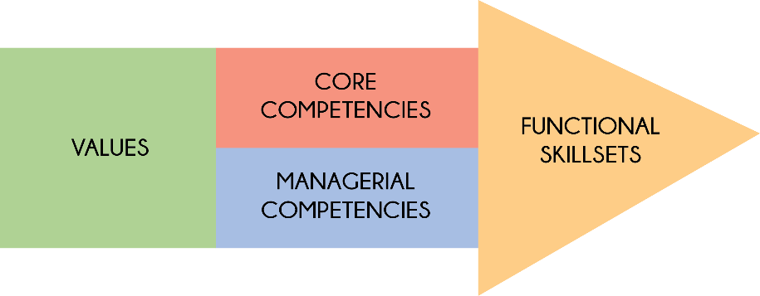

Values:
- Exemplifying integrity
- Demonstrating commitment to UNFPA and the UN system
- Embracing cultural diversity
- Embracing change

Core Competencies:
- Achieving results
- Being accountable
- Developing and applying professional expertise/ business acumen
- Thinking analytically and strategically
- Working in teams/ managing ourselves and our relationships
- Communicating for impact

Managerial Competencies:
- Providing strategic focus
- Engaging internal/ external partners and stakeholders
- Leading, developing and empowering people/ creating a culture of performance
- Making decisions and exercising judgment

Functional Skill Set:
- Advocacy/ Advancing a policy-oriented agenda
- Leveraging the resources of national governments and partners/ building strategic alliances and partnerships
- Delivering results-based programme
- Internal and external communication and advocacy for results mobilization

Languages:

Fluency in English. Depending on the duty station, a working knowledge of another UN language such as French, Spanish, Arabic, Chinese or Russian may be required.

6. Signatures/Certification:

Incumbent’s Name & Signature  (If Applicable) | <Enter Incumbent's Name Here>  <Date>
Immediate Supervisor’s Name & Signature | <Enter Supervisor's Name Here>  <Date>
Division Director’s Name & Signature | <Enter Division Director's Name Here>  <Date>

