JOB DESCRIPTION

Official Job Title: | Programme Specialist M&E
Duty Station: | Johannesburg, South Africa
Grade (Classified) | NOC
Post Number: | 130838
Post Type: | Rotational Non-Rotational
Classification Authority: |  | Date:

1. Organizational Location

The Programme Specialist M&E of the Swedish funded Joint United Nations Programme on SRHR/HIV and GBV Integration is located in the East and Southern Africa Regional Office (ESARO) based in Johannesburg, South Africa. S/He reports to the Project Coordinator based at UNFPA ESARO and falls under the overall leadership of the HIV Prevention Advisor. The Programme Specialist M&E will work closely coordinate efforts with the M&E Advisor and the M&E Manager of the Safeguard Young People Programme, select programme staff and other key UNFPA ESARO technical, programme and operational staff for the effective implementation of the key components of the Joint Programme and UNFPA’s efforts on SRHR/HIV. S/He is overall responsible for the monitoring and evaluation of the Joint UN Regional Programme and will work in close collaboration with regional focal persons from UNAIDS, UNICEF and WHO and the M&E Focal Persons responsible for the Joint UN Programme in the participating countries to ensure that the Joint United Nations Programme on SRHR/HIV and GBV is effectively monitored and evaluated. S/he will support the strengthening of the monitoring and reporting of UNFPA’s efforts on HIV prevention. She/he is responsible for providing policy, programme and operational management guidance to the UN partners, programme staff and countries in an integrated and coordinated manner for the successful implementation of the programme deliverables/results. S/He will work together with the Programme/Finance Specialist and an Admin/Finance Associate to ensure the proper coordination, management and implementation of the Joint UN programme.

2. Job Purpose

The Programme Specialist M&E will oversee the monitoring and evaluation of the Joint UN Regional Programme on SRHR/HIV and GBV Integration and work closely with the Regional Interagency Working Group and agency assigned focal persons to coordinate the monitoring, evaluation and reporting of the Joint UN Programme and support strategic information related activities on the Joint UN Programme. S/he will also support the monitoring and reporting on the efforts of UNFPA in relation to HIV prevention. S/He is responsible for providing monitoring and evaluation guidance to UN partners, programme staff and countries that are part of the programme in an integrated and coordinated manner to ensure that the results of the Joint Programme are effectively monitored and reported to show impact.

The Programme Specialist M&E will ensure regular communication with agency and country programme managers, M&E focal persons responsible for monitoring and reporting on the programme. All monitoring, evaluation and reporting related commitments will be the responsibility of the Programme Specialist M&E. S/He will provide strategic advice and ensure appropriate coordination within ESARO and with concerned COs and various partners on the monitoring and evaluation of the programme. The Programme Specialist M&E will work with the Project Coordinator to update the regional partners, the Regional Director, R-UNDG and the Regional Programme Steering Committee Meeting of the progress of the programme and partnership with Sweden and other funders in respect to the programme, its results and sustainability.

3. Major Activities/Expected Results

The Programme Specialist M&E is responsible for the monitoring, evaluation and reporting of the Joint UN Programme on SRHR/HIV and GBV Integration, related Strategic Information Activities and provides programmatic support to countries. S/he provides support to ensure the effective implementation, monitoring and evaluation of the efforts of UNFPA on HIV prevention:

- Manage and provide guidance and oversight for overall monitoring and evaluation, strategic information and reporting at regional and country levels
- Manage and coordinate all M&E and Strategic Information activities, including timely and quality reporting, knowledge generation and management;
- Manage monitoring, reporting and contribute to the evaluation of the programme;
A. Coordination and technical support of monitoring and evaluation:
- Coordinate the M&E efforts of the four UN agencies and the ten participating countries to to track the results of the implementation of the Joint UN Regional Programme at regional and country level and the work of UNFPA on HIV prevention based on the agreed upon results framework.
- Ensures that data is provided and collected against the agreed upon indicators using the defined reporting tools and ensures that the SRHR/HIV programme results and those relating to UBRAF are accurately captured, measured and reported.
- Provides technical support and builds the capacity of countries to ensure that the necessary M&E systems are established to capture and report on progress in relation to the project, and UNFPA activities on HIV prevention and that reports are submitted timeously and to monitor data quality.
- Manages the collation of baseline data in relation to the M&E Framework and ensures that agency and country reports are submitted by the the participating UN agencies and countries in good time.
- Respond to technical requests from countries and undertake country visits to support countries in strengthening their M&E systems and identify adaptations as may be needed.
- Works with the Programme Manager and the Regional Interagency Working Group in designing the mid-term and end of project evaluation.
- Coordinates and develops programmatic reports for donors and the Regional Programme Steering Committee on progress made at regional and country level.

B. Strategic Information
- Coordinate the efforts of the UN partners to support countries to strengthen their national health management information systems so that they are able to monitor the provision of integrated SRHR/HIV and SGBV services.
- Work with UNAIDS and the UNFPA Strategic Information Units to integrate key indicators relating to SRHR and GBV into the regional information hub and country situation rooms.
- Work with the four UN partners and the 10 participating countries to produce annual updates on SRHR/HIV and SGBV to track regional and country progress in meeting national/regional targets.
- Document lessons learnt, share knowledge and disseminate good practices, on the monitoring and evaluation of SRHR/HIV and SGBV in the ESA region;
- Support countries to prepare manuscripts and abstracts for submission to international, regional and national journals, conferences and other fora to share lessons learnt.
- Facilitate, act as resource person, and join if required any external supervision and evaluation missions.

C. Development of work plans and reporting
  - Review and provide input in the preparation of annual country work plans from an M&E perspective and ensure that the monitoring and evaluation indicators are aligned to the M&E Framework.
- Coordinate the development of a semi-annual, annual and other project reports as may be required that shows progress in relation to the results framework at country and regional level, with a focus on impact.
- Develop and present annual programme results to the Regional Programme Steering Committee that captures both the direct and catalytic actions of the programme.
- Provide an analysis of the data, its implications for programme implementation and initiate operational research activities that will inform and strengthen programme implementation.
- Oversee the design of the mid-term and end-of-project evaluation in collaboration with the four partner agencies and the ten countries and its implications for programme management.

4. Work Relations

External partners include the programme's main donor (Sweden), UN agencies in particular the regional teams of UNAIDS, UNICEF and WHO, donor and the participating governments of the countries concerned, NGOs, Academia, Research Institutions, professional associations, and international experts, in developing a network of technical experts and institutions for technical and programme support.

The Programme Specialist M&E will work closely to coordinate the monitoring and reporting on programme performance with the M&E Advisor and the M&E Manager of the Safeguard Young People Programme. S/he will work with internal partners including UNFPA ESARO programme, operational and technical staff, resource mobilisation and partnership Adviser, Communication Team; programme and technical staff in UNFPA country offices involved in the programme; relevant UNFPA headquarters units. In all activities, s/he supports the Project Coordinator and the HIV Adviser to foster collaboration within the Integrated SRHR Unit and Regional Office, particularly amongst the team involved in the implementation of the programme.

5. Job Requirements

- Education: Master Degree in Statistics, Demography, Social Sciences, or Public Health; Postgraduate training in monitoring and evaluation an added advantage.

Knowledge and Experience:

- 5 years’ experience in monitoring and evaluation, results based programme development and management.
- Experience in developing indicators, data collection tools, M&E plans and results frameworks in HIV and SRH.
- Knowledge of National Health Information Systems desirable.
- Ability to write clear and comprehensive reports.
- Experience in capacity building on M&E.
- Excellent computer skills especially Access, Excel, SPSS and GIS.
- Fluent in English with excellent writing, analysis and communication skills Excellent Writing skills in English. Knowledge of other UN language is an asset.

Required Competencies:

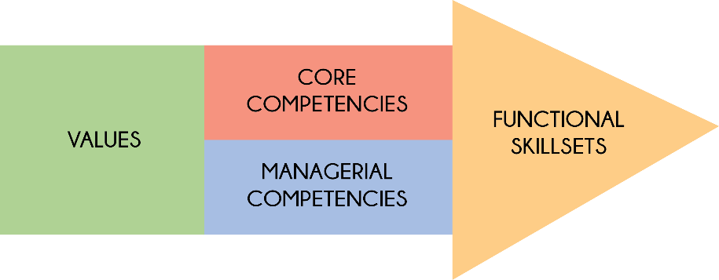

Values:
- Exemplifying integrity
- Demonstrating commitment to UNFPA and the UN system
- Embracing cultural diversity
- Embracing change

Core Competencies:
- Achieving results
- Being accountable
- Developing and applying professional expertise/ business acumen
- Thinking analytically and strategically
- Working in teams/ managing ourselves and our relationships
- Communicating for impact

Managerial Competencies:
- Providing strategic focus
- Engaging internal/ external partners and stakeholders
- Leading, developing and empowering people/ creating a culture of performance
- Making decisions and exercising judgment

Functional Skill Set:
- Advocacy/ Advancing a policy-oriented agenda
- Leveraging the resources of national governments and partners/ building strategic alliances and partnerships
- Delivering results-based programme
- Internal and external communication and advocacy for results mobilization

Languages:

Fluency in English. Depending on the duty station, a working knowledge of another UN language such as French, Spanish, Arabic, Chinese or Russian may be required.

6. Signatures/Certification:

Incumbent’s Name & Signature  (If Applicable) | <Enter Incumbent's Name Here>  <Date>
Immediate Supervisor’s Name & Signature | <Enter Supervisor's Name Here>  <Date>
Division Director’s Name & Signature | <Enter Division Director's Name Here>  <Date>

